COURSE: CLOUD AND NETWORK SECURITY _C1-2024

STUDENT NAME: LENNIE NTHIGA
STUDENT NO: cs-cns07-24170
OCTOMBER 11,2024

WEEK 4 ASSIGNMENT 2
Assignment 2: Packet Tracer WLAN configuration

Contents
INTODUCTION 3
THE NETWROK TOPOLOGY 3
Part 1: Configure a Home Wireless Router. 4
Step 1: Change DHCP settings. 4
Part 2: Configure a WLC Controller Network 6
Step 1: Configure VLAN interfaces. 6
Step 2: Configure a DHCP scope for the wireless management network. 6
Step 3: Configure the WLC with external server addresses. 6
Step 4: Create the WLANs. 7
CONCLUSION 8

INTODUCTION
WLAN Is a wireless local-area network (WLAN) being a group of collocated computers or other devices that form a network based on radio transmissions rather than wired connections. The exercise would show how wireless network is configured and security features are set with the different security protocols

THE NETWROK TOPOLOGY
Home wireless router
Laptop ,tablet, phone ,cable modem
R1 /ISR 4331 – Integrated service router provides secure connections between an organization's internal network and the public internet.
SW1/3650-24PS - Cisco Catalyst 3650 Series enterprise-class standalone and stackable access-layer switches
WLC1/WLC-3504 - Wireless Controller- provides centralized control that manages wireless network access points that allow wireless devices to connect to the network
LAP1/3702i-is a cisco access point those functions as a hub that links all stations together that serves as the focal point for communications, increasing the communication range of wireless users.
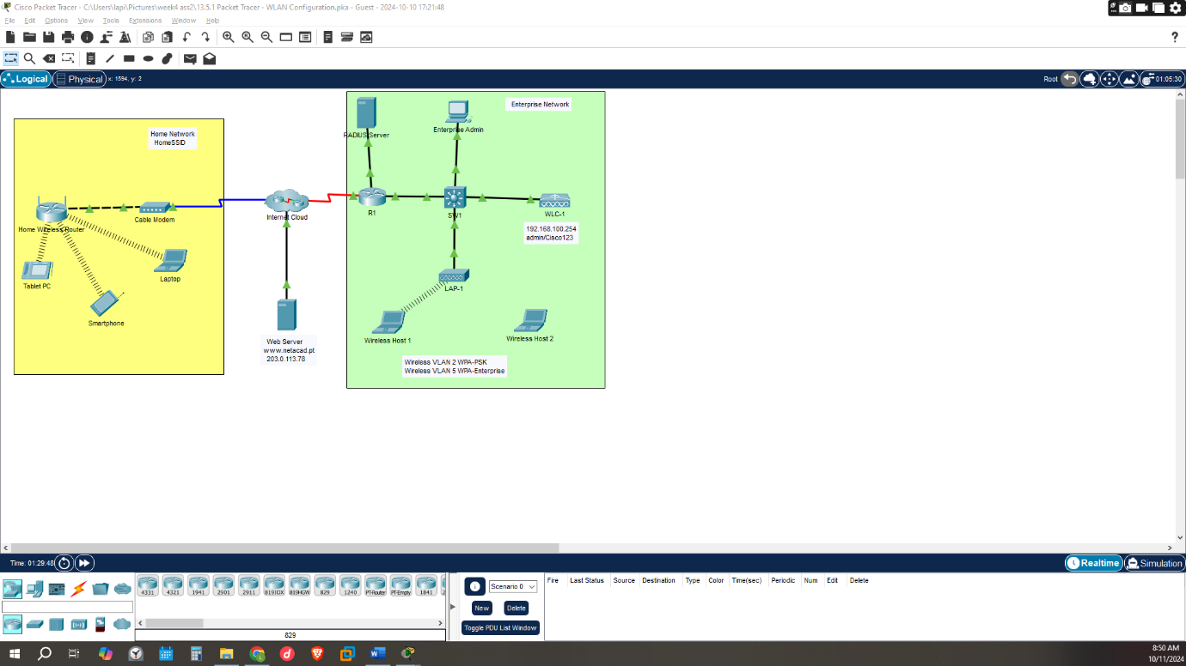

Part 1: Configure a Home Wireless Router.

Step 1: Change DHCP settings.
DHCP -dynamic host configuration protocol this is a protocol that assigned Ip addresses to hosts in a network and other configurations
In this case in the network, we would limit the number to 20 connections and specify the DHCP server to start assigning the Ip addresses from 192.168.6.3 thus the first device to be 192.168.6.3
the WLAN would be given the name HomeSSID with 6-24 GHZ channel which would be used for information transfer
a security protocol WPA2 -PERSONAL would be assigned with encryption being AES meaning
WPA2-personal – usually used in home networks and small work areas , a pre-shared key is used to join the network securely
WPA2-enterpsrise- requires users to authenticate via a central server (often RADIUS) using credentials, such as usernames and passwords or certificates. designed for cooperation’s/organizations
AES and TKIP encryptions - TKIP is a lower end encryption protocol (WEP2) and AES is a higher end (WPA2/802.11i) encryption protocol.

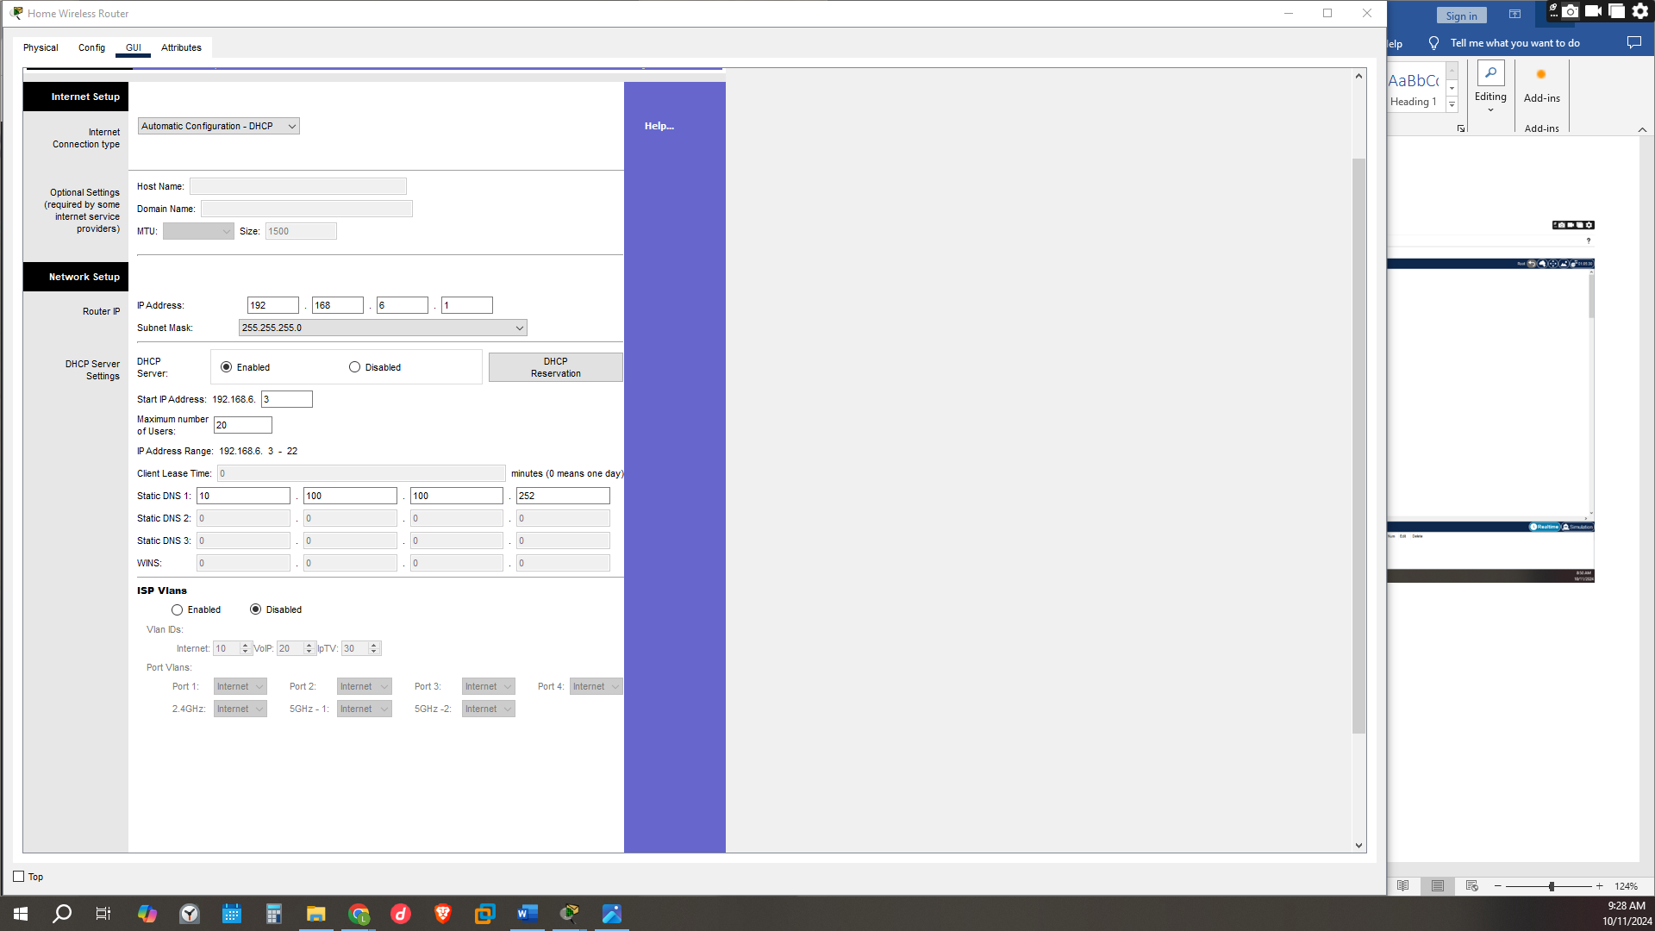
The image below shows the connecting the tablet to the pc and the connection being successful.
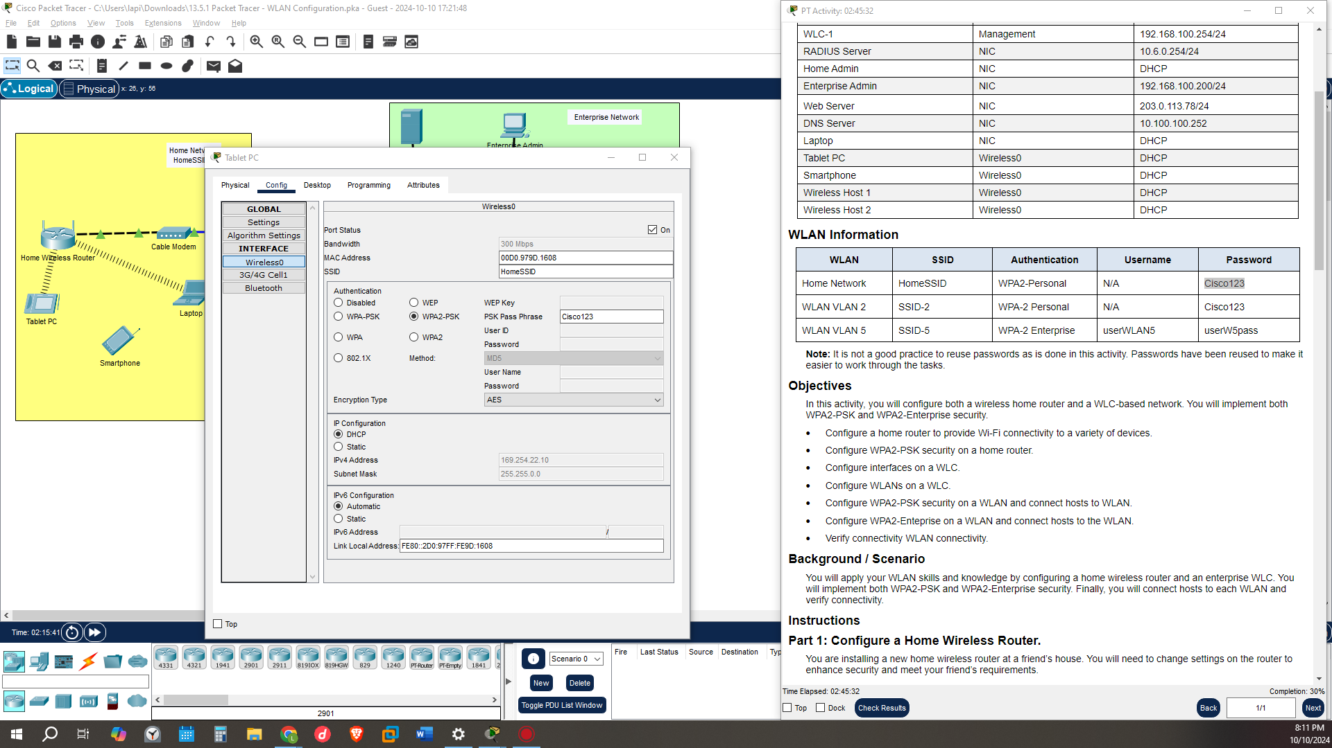
To know the successful connection of the devices to the network/WLAN we can pin the ips and get feedback
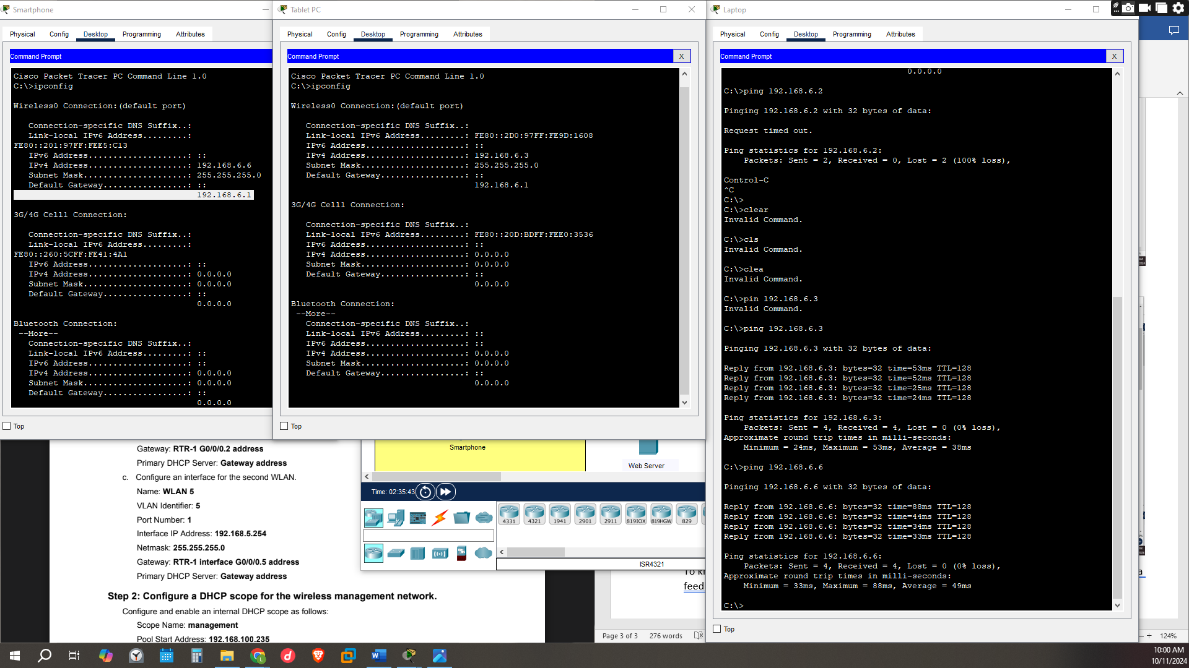

Part 2: Configure a WLC Controller Network
WLC- wireless LAN controller- is a network element that manages the configuration and management of the Aps(Access Points) in a domain.

Step 1: Configure VLAN interfaces.
We would be creating two interfaces for two WLANs for the purpose of having separation on the users one can be given fir guests and the other of employees/staff r recognized individuals this would reduce the interference of one network to others
Thus, the creation of WLAN 2 and WLAN5.
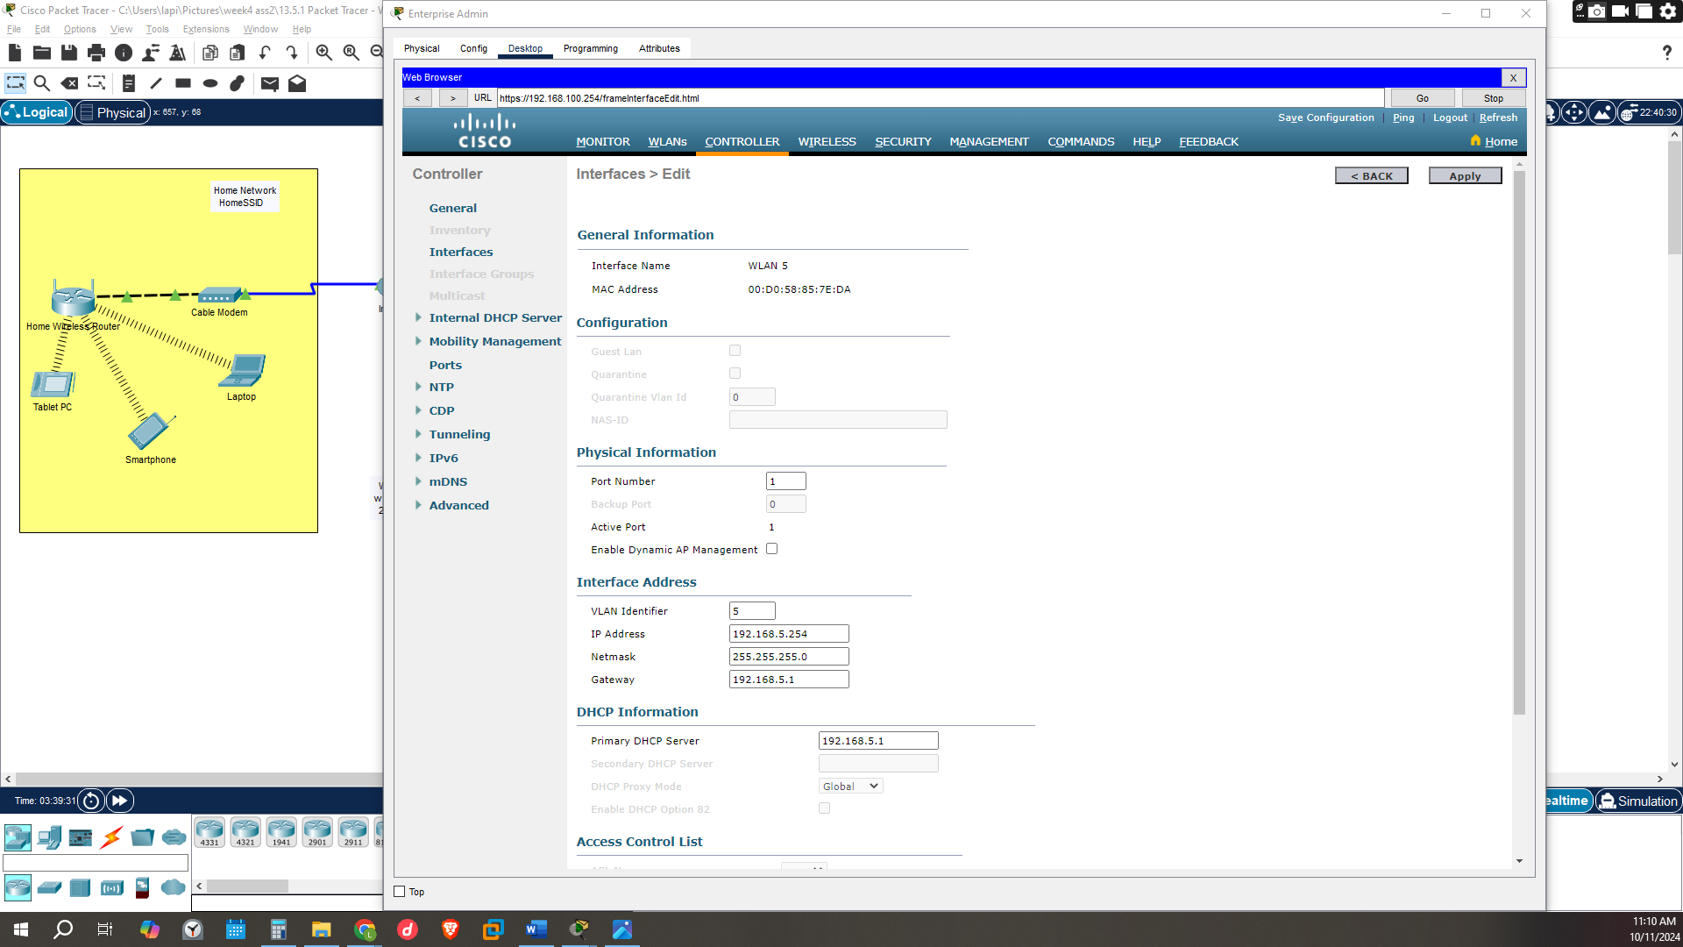

Step 2: Configure a DHCP scope for the wireless management network.
The DHCP would be configured for the assigning of Ip address to the users who would join the network by limiting the Ip addresses by the Pool Start Address: 192.168.100.23 Pool End Address: 192.168.100.245(the last Ip to be given)
- Network: 192.168.100.0
- Netmask: 255.255.255.0
- Default Routers: 192.168.100.1

Step 3: Configure the WLC with external server addresses.
RADIUS server is a central server that provides authentication and authorization services for remote users who access a network mostly used in WPA2-ENETERPRISE security protocol which a user would need to submit a usernames and passwords or certificates.
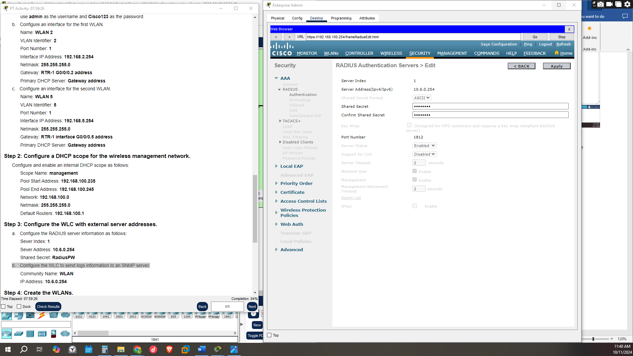

Step 4: Create the WLANs.
WLAN2 and WLAN5 would be created with its own ssid name for differentiation
Thus, WLAN2 would have SSID name SSID-2 with security protocol WPA2-PSK
Thus, WLAN5 would have SSID name SSID-5 with security protocol being both 802.1x - WPA2-Enterprise for using the RADIUS server
However, for this exercise Cisco doesn’t have wpa2-enterprise security protocol
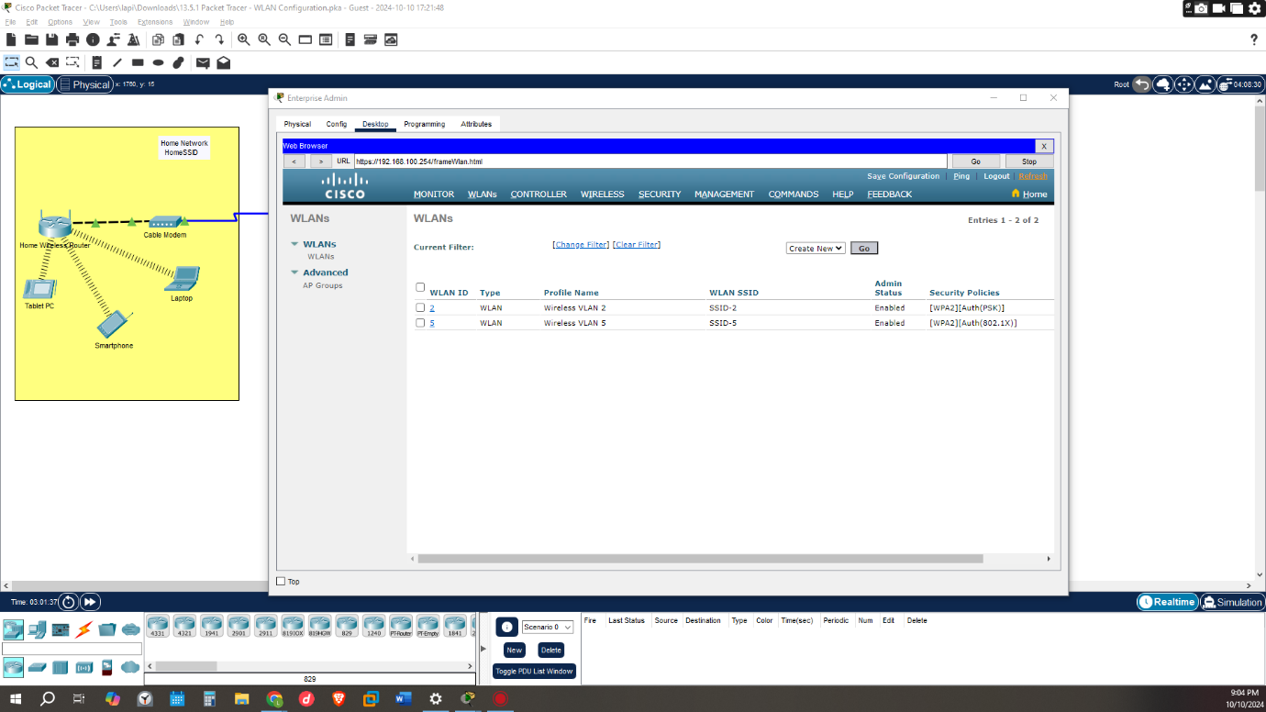
The final connection being
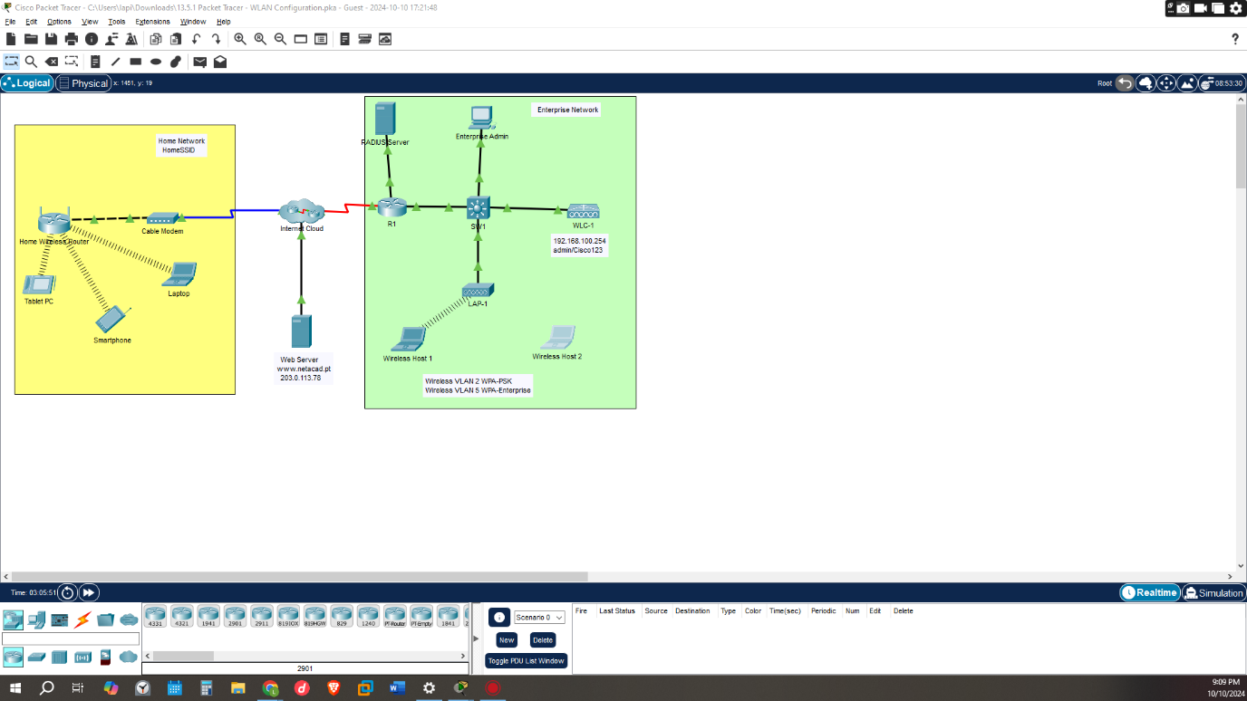

CONCLUSION
Its important to create different WLANS for user basis to reduce the security risk and the interface of users and the organizations staff .by doing this different security protocols can be kept in place and logs be recorded and stored separately for future analysis .by having a wireless controller one is able to increase the scalability of the network by having a single management area for controlling different access points

